University of electronic and science technology of china
UESTC

DIGITAL SIGNAL PROCESSING
Topic N2
Why the frequency spectrum is meaningful, talk about some engineering applications of signal spectrum

Prepared by: SADOUN T/S
ID: 201224020111


2013/2014

SUMMARY

Introduction 2
Time domain 3
Frequency domain 4
Why frequency spectrum/ frequency domain: 5
Some engineering applications 7
Conclusion 9

Introduction
The analysis of an electrical signal is a fundamental concern for many engineers and scientists. Especially now, by means of transducers, we can change lot of basic parameters into an electrical signals. Doing that, gives us a lot of ways to study such as signals, and let us getting lot of information about it, furthermore, designing systems will be clear.
We can look at electrical signals from different perspectives, and each of these different ways of analyzing or looking at a problem often lends its own unique insights. Among these looking ways, we cite the frequency spectrum, one of the more meaningful domains to extract information from any signal. In order to show why it’s more meaningful, we should compare it to others.
Frequency spectrum, refer to frequency domain, it exist another well-known called time domains, and less known, the modal domain. These domains, especially the two first one, time and frequency, are closely interchangeable; that is, no information is lost in changing from one domain to another. Developing these two concepts can show us how is frequency domain meaningful.
The interchangeability between these domains is assured via different mathematic tools. And one of the greatest tools discovered and the largest used one is, surely, the Fourier transform. It assures not only the interchangeability between them, but it makes it in an easiest way.

Time domain
The traditional way of observing signals is to view them in the time domain. The time domain is a record of what happens to a parameter of the system versus time. For instance, Figure 1.1 shows a simple spring-mass system where we have attached a pen to the mass and pulled a piece of paper past the pen at a constant rate. The resulting graph is a record of the displacement of the mass versus time, a time-domain view of displacement.
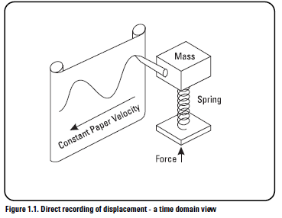

So that, in time domain, we get the representation of a given system’s variation during a given time.
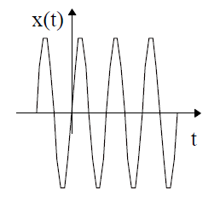

In such representation the amount of information that we can get from that system is tiny. We can get such as; the amplitude of our signal, its frequency, and period in case of a periodic signals.

Frequency domain
Over than one hundred years ago, Baron Jean Baptiste Fourier showed that any waveform that exists in the real world can be generated by adding up sine waves. Conversely, we can break down our real signal into these same sine waves. It can be shown that this combination of sine waves is unique; any real world signal can be represented by only by one combination of sine waves.
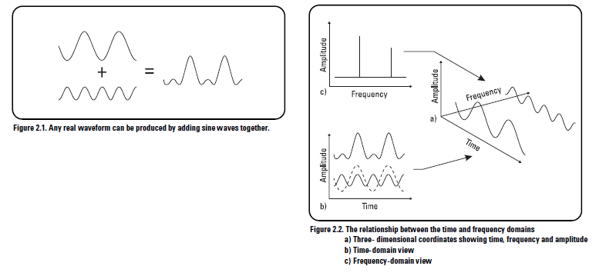

These two figures show clearly the different domain. Figure 2.2a is a three-dimensional graph of this addition of sine waves. Two of the axes are time and amplitude, familiar from the time domain. The third axis, frequency, allows us to visually separate the sine waves that add to give us our complex waveform. If we view this three-dimensional graph along the frequency axis we get the view in Figure 2.2b. This is the time domain view of the sine waves. Adding them together at each instant of time gives the original waveform.
However, if we view our graph along the time axis as in Figure 2.2c, we get a totally different picture. Here we have axes of amplitude versus frequency, what is commonly called the frequency domain. Every sine wave we separated from the input appears as a vertical line. Its height represents its amplitude and its position represents its frequency. Since we know that each line represents a sine wave,

we have uniquely characterized our input signal in the frequency domain. This frequency domain representation of our signal is called the spectrum of our signal.
It is very important to understand that we have neither gained nor lost information; we are just representing it differently. We are looking at the same three dimensional graph from different angles. This different perspective can be very useful.

Why frequency spectrum/ frequency domain:
- Suppose we wish to measure the level of distortion in an audio oscillator. Or we might be trying to detect the first sounds of a bearing failing on a noise machine. In each case, we try to detect a small sine wave in the presence of large signals. Figure 2.5a shows a time domain waveform that seems to be a single sine wave. But Figure 2.5b shows in the frequency domain that the same signal is composed of a large sine wave and significant other sine wave components (distortion components). When these components are separated in the frequency domain, the small components are easy to see because they are not masked by larger ones.
The frequency domain’s usefulness is not restricted to electronics or mechanics. All fields of science and engineering have measurements like these where large signals mask others in the time domain. The frequency domain provides a useful tool for analyzing these small, but important, effects.

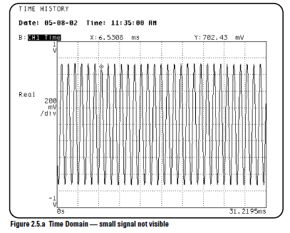
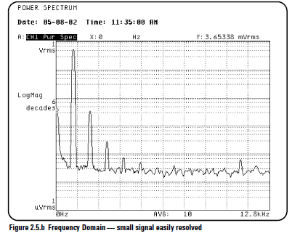

- Frequency spectrum show us the whole spectrum of a given signal, meaning of that is; we can have an information about the whole frequencies contained in that signal, we can get more information concerning the behavior of each component.
- Moving to filtering, in a time domain, passing a signal through a filter, we still get a signal, but no real information about what that signal subjected as changes, but we know nothing about what is really happening in a such filtering operation, however; moving to frequency domain, using the spectrum, filtering become more obvious, the changes in the signal’s behavior becomes obvious even small can be.
- Another reason, maybe showing more the helpful of a frequency domain than its meaningful, but still, I think it’s important to tell it; that’s deal with computing. In a lot of cases, it’s difficult to compute in time domain the output of any but the simplest networks (complicated integrals), however; it’s easier to compute the output by transforming to frequency domain.
- Frequency spectrum obviously give us how much each frequency, contains in a given signal, is amplified when we pass that signal through an amplifier, we will get more details than if we analyze it in a time domain.
- Some operations such as: Shifting (especially for a periodic signals), doesn’t appear in time domain, however; frequency spectrum show what’s really happened after applying such as operation to a signal.
- If we are in radar field, we need more to know about the behavior of the received echoes, as small they are, a frequency spectrum is a powerful tool to deal with it; it makes those echoes more meaningful.
- When in a time domain we get information about the amplitude, the periodicity/non-periodicity, duration, and the shape, moving to spectral domain, we can get, added to that, divers frequencies, the distribution of power, the overlaps, the mismatching, the influence of noise over our spectrum… .

Some engineering applications

- The widely use of the spectrum analyzer, can clearly show us the meaningful and the power of using frequency spectrum. This tool, frequency spectrum, is widely used in engineering fields, as examples, we can give:

- The well-known one that maybe lot of people use, is in the voice analyzing, as a simple example; the use of equalizer in music players, to accentuate/ dis-accentuate any desired frequency (low, medium, high); for more music enjoying.
- From the same idea given before, another application occurs, it’s the voice recognition, by correlating a given frequency spectrum with another to measure the similarities, so that we can approximately match a voice with a person.
- Used to predict the output of any network from its frequency response.
- Largely used in most of microwaves calibration test station;
- Lot of engineering applications, of frequency spectrum, are used in military domain, especially in radar equipment and other telecommunication system.

I will talk about one of the famous engineering applications of the frequency spectrum, the spectrum analyzer.
- The main idea is based on analyzing the spectrum of a given signal to extract a large amount of information from it. The first problem observed, is how to analyze a large bandwidth with the same equipment. The first solution is to use lot of filter. Electronic filters can be built which pass a narrow band of frequencies. If we were to add a meter to the output of such a band pass filter, we could measure the power in the portion of the spectrum passed by the filter.

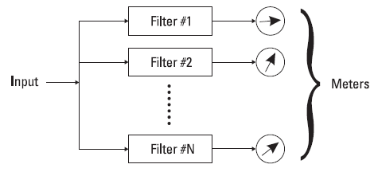
Simplified parallel filter analyzer

- In the upper Figure we show a simple schema of a simplified parallel filter analyzer. Each filter is tuned to a different frequency. If the center frequencies of these filters are chosen so that the filters overlap properly, the spectrum covered by the filters can be completely characterized as in the follow Figure.
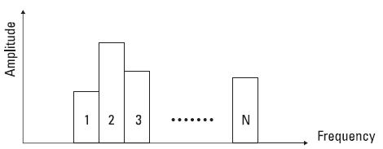
Parallel filter analyzer output

Such as structure use the FFT, can give us information just by analyzing the spectrum of an input, its advantage is being fast in analyzing but has a limited resolution and high cost. Later we see other kinds of applications in the same meaning, such as the sweep spectrum analyzer, based on the use of one filter and sweep it slowly through the frequency range of interest, it can improve the cost and the resolution, but it’s slow in analyze.

Recently, another kind of analyzer was developed; it’s the dynamic spectrum analyzer, which offers the best features of the parallel and sweep analyzer.

Conclusion

It is very common for information to be encoded in the sinusoids that form a signal. This is true of naturally occurring signals, as well as those that have been created by humans. Many things oscillate in our universe. A simple example, speech is a result of human cords’ vibrations; stars and planets change their brightness as they rotate on their axes and revolve around each other; ships on sea generate periodic displacement of water, and so on. The shape of the time domain waveform is not important in these signals; the key information is in the frequency, phase and amplitude of the component sinusoids. Using the frequency spectrum, leading in frequency domain, allowed us more information about these parameters.

